Name: Ugochukwu Achara, Samuel Ibikunle, Thylia Watson
Assignment 3

- Create a scatterplot of engine size (displ) vs highway mileage (hwy). Map class to color. Add a title and axis labels. [2 points]
ggplot(mpg, aes(x = displ,y = hwy, color = class)) +
geom_point() +
labs(
title = "Engine Size vs Highway Mileage",
x = "Engine Size",
y = "Highway Mileage",
)
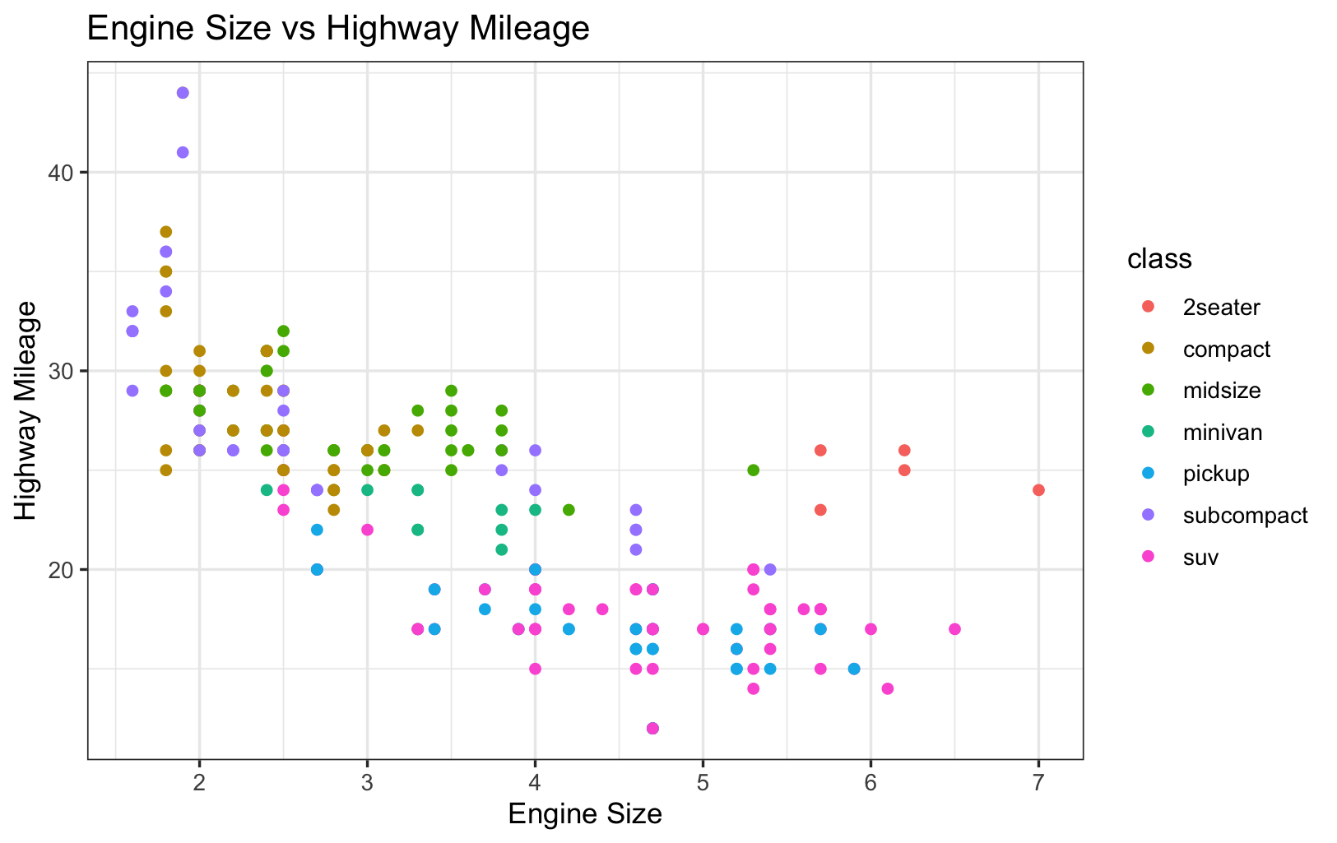
- Make a bar chart of count of cars by class. Rotate x-axis labels if needed. [2 points]
ggplot(mpg, aes(x=class)) +
geom_bar(fill = "Navy blue") +
labs(
title = "Cars by Class",
x = "Class",
y = "count"
)
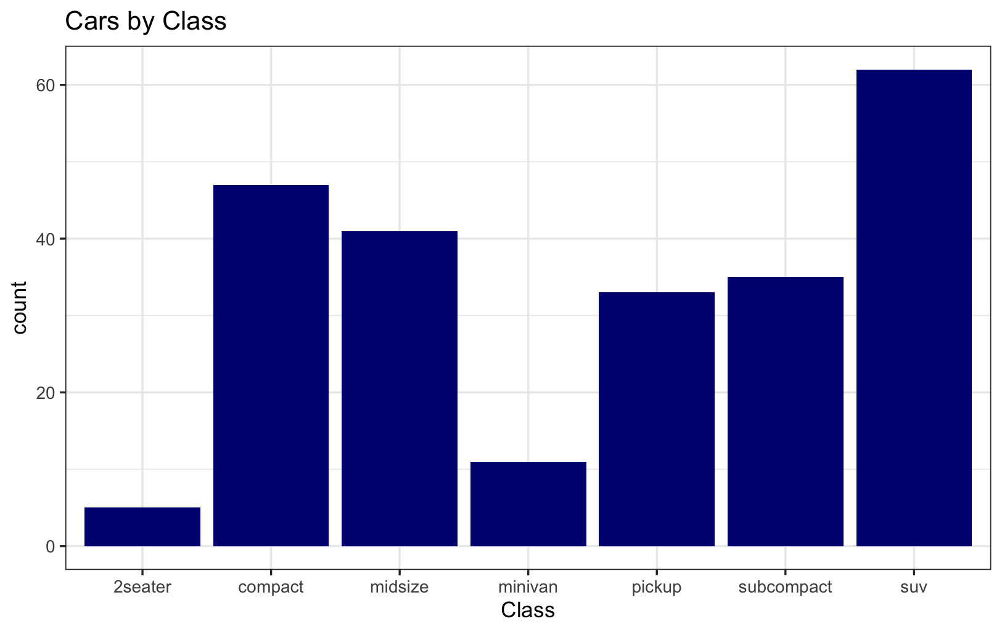
- Use the heights dataset Plot the distribution of female heights: a) Histogram with binwidth = 1 b) Density plot with geom_density(). [2 points]
#a)Histogram with binwidth = 1
heights |>
filter(sex == "Female") |>
ggplot(aes(x = height)) +
geom_histogram(binwidth = 1, fill = "pink", col = "brown")
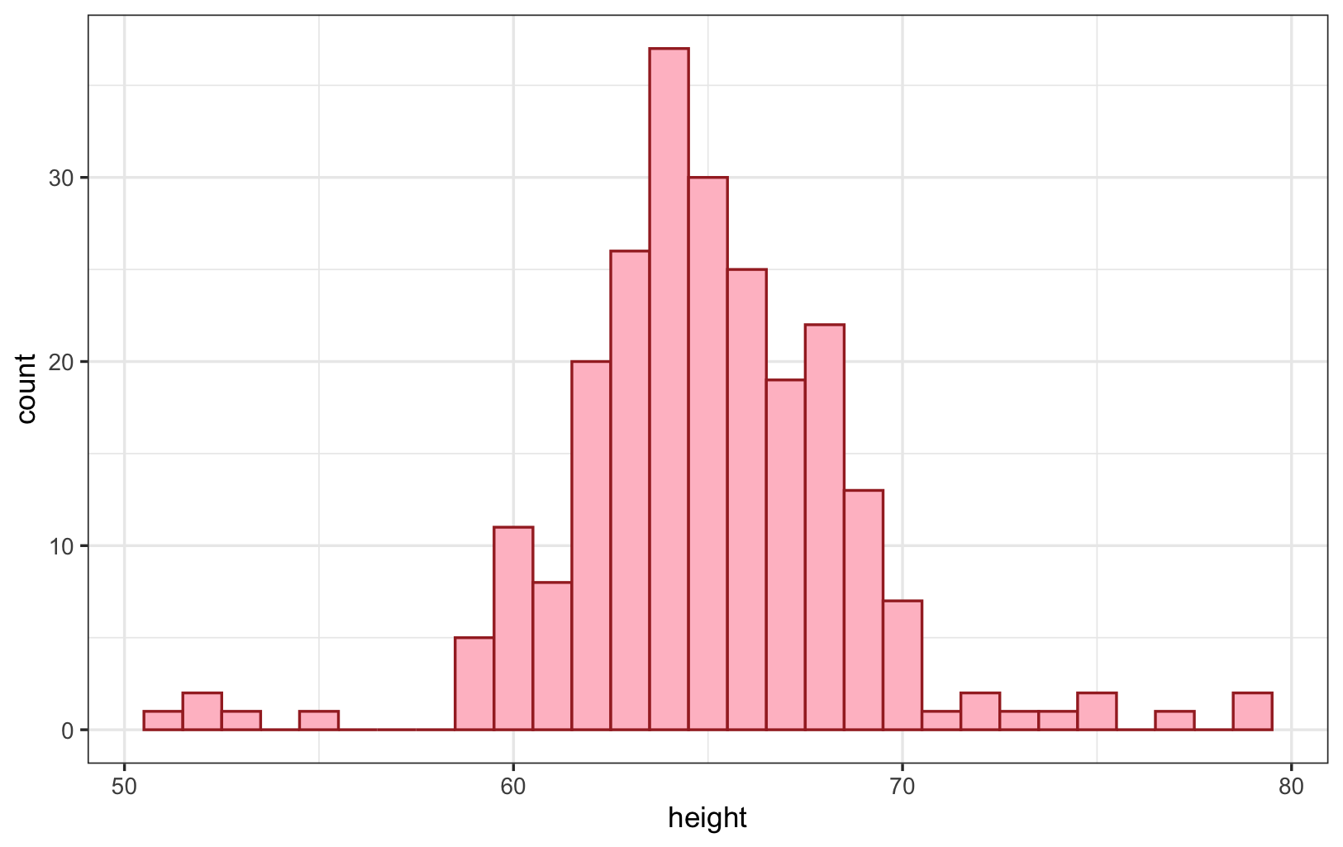

# b) Density plot with geom_density()
heights |>
filter(sex == "Female") |>
ggplot(aes(x = height)) +
geom_density(fill = "purple", alpha = 0.4)
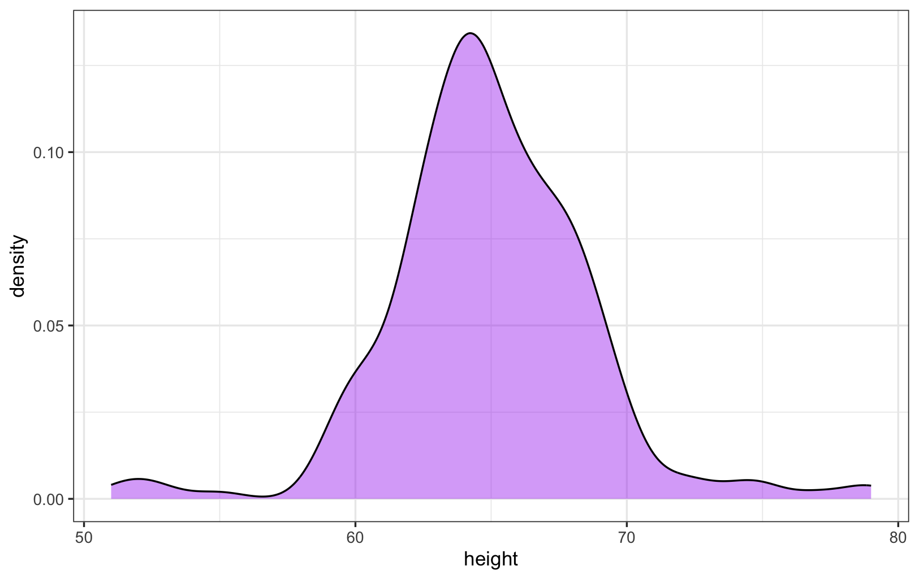
- Compare life expectancy trends over time for two countries (Brazil, Japan) in the gapminder dataset using ggplot2? [2 points]
gapminder |>
filter(country %in% c("Brazil", "Japan"), !is.na(life_expectancy)) |>
ggplot(aes(x = year,y = life_expectancy, fill = country)) +
geom_area() +
labs(
title = "Life expectancy by Country",
x = "Year",
y = "Life Expectancy"
)
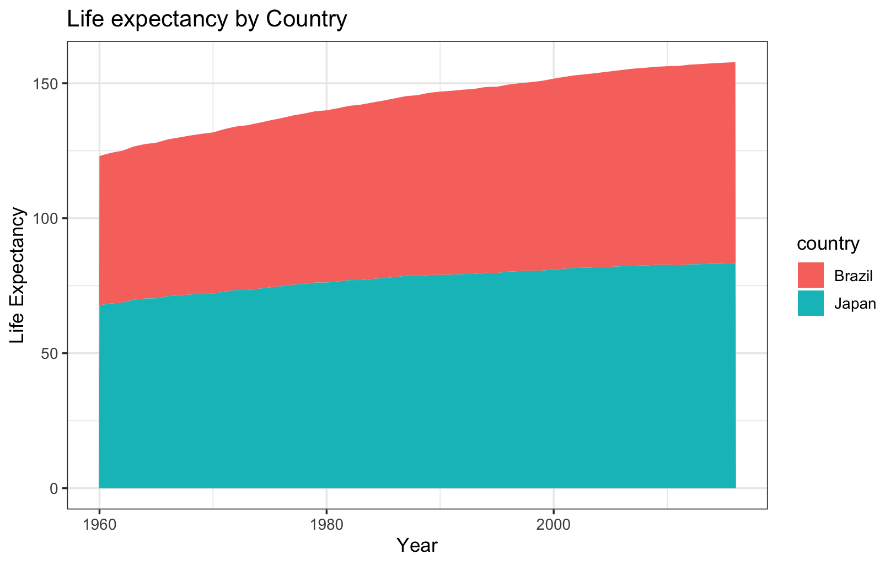
- Visualize the relationship between horsepower and miles per gallon in the mtcars dataset using ggplot2, with a regression line? [2 points]

mtcars |>
ggplot(aes(x = mpg, y = hp)) +
geom_point(color = "navyblue", size = 2) +
geom_smooth(method = "lm", color = "black") +
labs(
title = "Horse Power vs Miles Per Gallon",
x = "Miles Per Gallon",
y = "Horse Power"
)
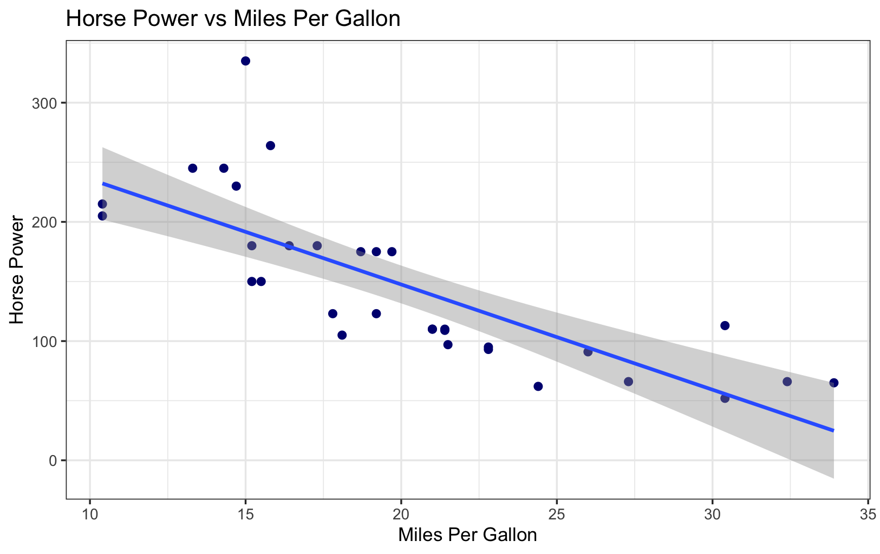

Output on console
> #1) Create a scatterplot of engine size (displ) vs highway mileage (hwy). Map
> #class to color. Add a title and axis labels. [2 points]
> ggplot(mpg, aes(x = displ,y = hwy, color = class)) +
+ geom_point() +
+ labs(
+ title = "Engine Size vs Highway Mileage",
+ x = "Engine Size",
+ y = "Highway Mileage",
+ )
> #2) Make a bar chart of count of cars by class. Rotate x-axis labels if needed. [2 points]
> ggplot(mpg, aes(x=class)) +
+ geom_bar(fill = "Navy blue") +
+ labs(
+ title = "Cars by Class",
+ x = "Class",
+ y = "count"
+ )
> #a)Histogram with binwidth = 1
> heights |>
+ filter(sex == "Female") |>
+ ggplot(aes(x = height)) +
+ geom_histogram(binwidth = 1, fill = "pink", col = "brown")
> # b) Density plot with geom_density()
> heights |>
+ filter(sex == "Female") |>
+ ggplot(aes(x = height)) +
+ geom_density(fill = "purple", alpha = 0.4)
> gapminder |>
+ filter(country %in% c("Brazil", "Japan"), !is.na(life_expectancy)) |>
+ ggplot(aes(x = year,y = life_expectancy, fill = country)) +
+ geom_area() +
+ labs(
+ title = "Life expectancy by Country",
+ x = "Year",
+ y = "Life Expectancy"
+ )
> mtcars |>
+ ggplot(aes(x = mpg, y = hp)) +
+ geom_point(color = "navyblue", size = 2) +
+ geom_smooth(method = "lm") +
+ labs(
+ title = "Horse Power vs Miles Per Gallon",
+ x = "Miles Per Gallon",
+ y = "Horse Power"
+ )

